Artificial Intelligence and Machine Learning Project Documentation

# Introduction

* + **Project Title:** Pollen’s Profiling:Automated Classification Of Pollen Grains
  + **Team Members:**1.Kongara Keerthana(Team leader)

2.G.Kavya

3.K C Indusree

4.Sadum Thanuja

# Project Overview

* + **Purpose:**   
    1.The project aims to automate the classification of pollen grains using image processing  
    2.It reduces human effort and error in identifying pollen types under a microscope.  
    3.The system ensures faster, accurate, and consistent pollen profiling.  
    4.This supports research in botany, ecology, agriculture, and allergy studies.
  + **Features:**

˛ C Deep Learning Integration

`. Organized Project Structure

‘+⏷ç<‘1_˙ Image Upload & Prediction

# Architecture

# 

# SetUp Instructions

## Prerequisites:

* + 1. Python 3.7 or above
    2. Required Libraries: Flask, TensorFlow/PyTorch, OpenCV, NumPy
    3. Project folders: static/, templates/, model/
    4. Install dependencies: pip install -r requirements.txt

# Running The Application

After setting up the dependencies and environment variables as described earlier, follow the steps below to run the Pollen Grain application locally:

7s.¸•'˙ **Frontend :**

1. Hypertext Markup Languauge
2. Client Slide Scripting

## z‘\’ Backend (app.py server):

1.Python 2.Flask

1. TensorFlow 4.OpenCV

# User Interface

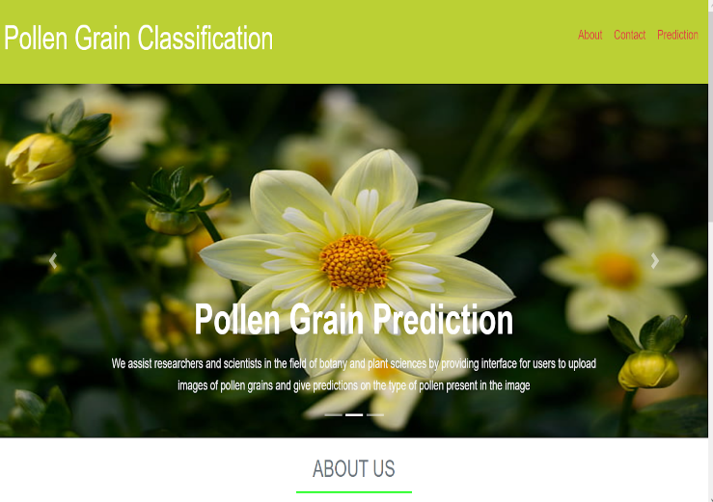 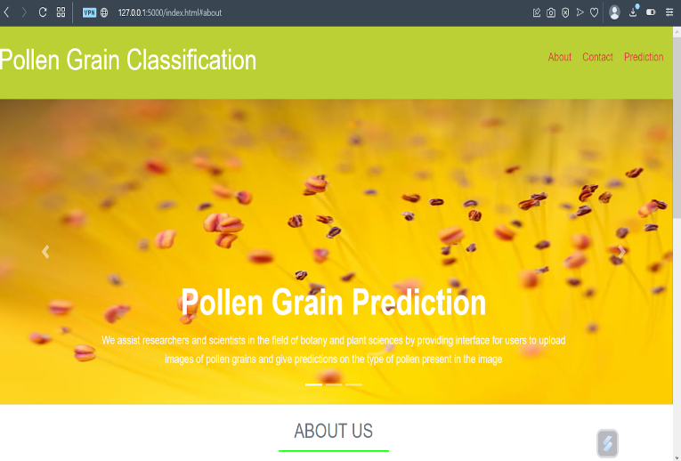

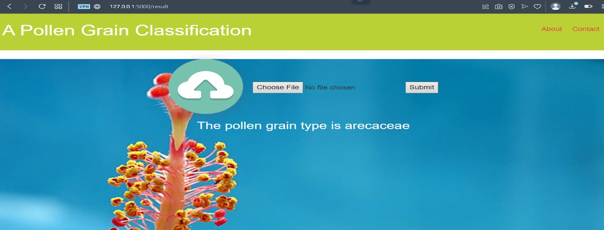

1. **Testing**

## Purpose of Testing:

To ensure that all parts of the pollen grain classification system—ML model, backend APIs, and frontend UI—function correctly, reliably, and efficiently before deployment.

## •˙Q Testing Strategy Overview:

⬛ ML Model Testing

⬛ Backend API Testing

⬛ Frontend (React) Testing

⬛ End-to-End Testing

# Known Issues:

While pollen grain classification is functional and reliable for most standard use cases, there are a few known limitations and issues that developers and users should be aware of.

* + Model Accuracy on Blurry or Noisy Images
  + No Input Validation for File Types (Backend)
  + Large File Uploads
  + No Authentication Implemented
  + No Rate Limiting or Abuse Protection

# Future Enhancements

* + Machine Learning & Model Enhancements
  + Frontend Features (React)
  + Authentication & User Management
  + Backend & Infrastructure
  + Database Improvements

# Conclusion

• The automated classification of pollen grains significantly improves accuracy and efficiency compared to manual methods.

• By leveraging image processing and machine learning, the system supports various fields like botany, agriculture, and environmental monitoring.

• This project lays the foundation for scalable and real-time pollen profiling, enabling better data-driven research and decision-making.